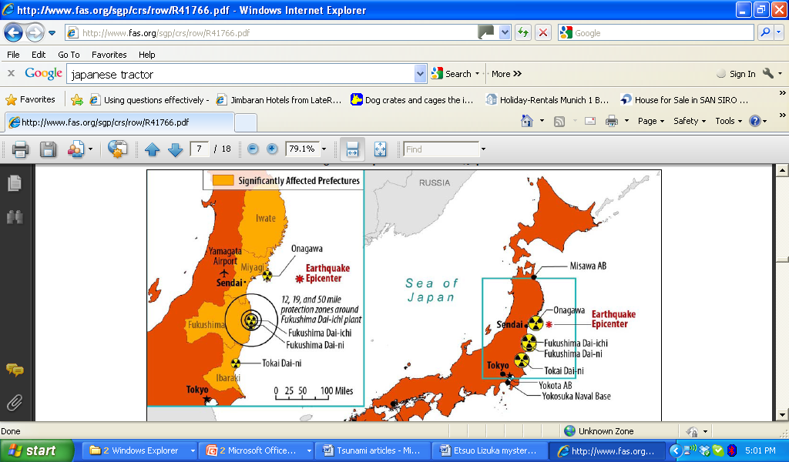

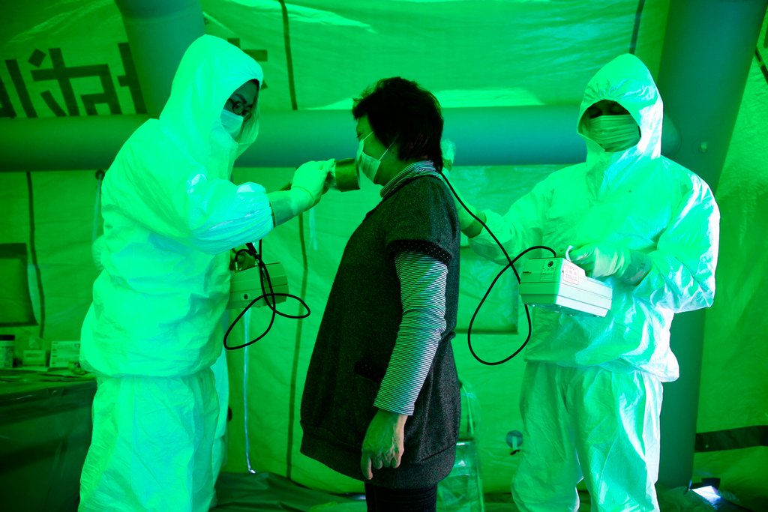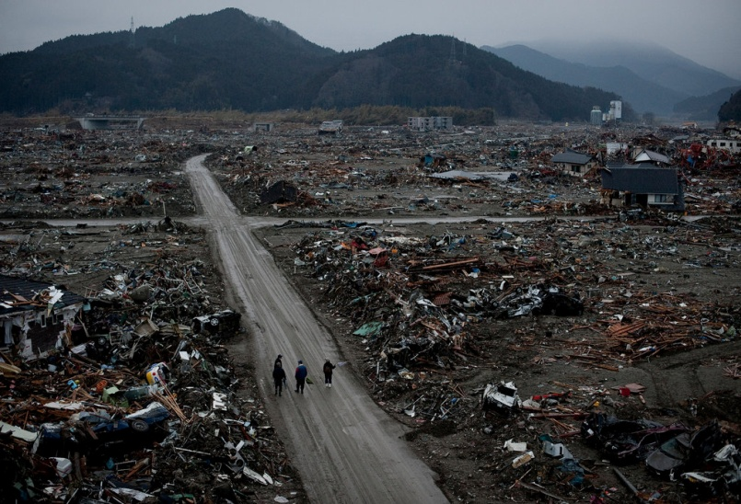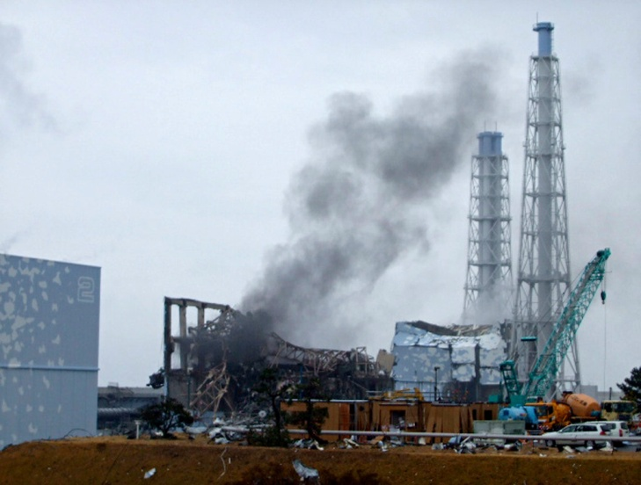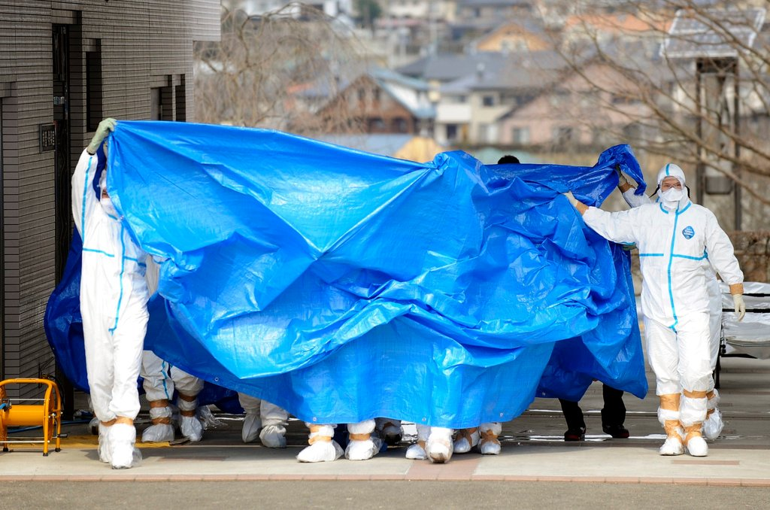

The Iseki tractor costs 2 million yen or £18 000.

In May 2011 Etsuo Lizuka receives a letter from the Agricultural Minister advising him that he will not be able to sell his crop this season.

An explosion of the Fukushima plant releases radiation into the atmosphere and surrounding areas leaving the soil and crops contaminated throughout the Fukushima prefecture.

Japan's Cabinet Secretary Yukio Edano said radiation levels in milk from a Fukushima farm and spinach grown in Ibaraki exceeded limits set by the government.

The earthquake triggered a tsunami wave which was 10 metres in height and moved at a speed on 800km per hour towards the North East coast.

By March 13th 9000 people are confirmed dead due to the Tsunami and a further 12 000 people are missing.

In April 2011 the Japanese Agricultural Minister banned the sale of agricultural products from the Fukushima prefecture due to the high levels of radioactive cesium found.

Etsuo Lizuka is a farmer who produces spinach, tomatoes and some other crops. The Lizuka farm is located in Ibaraki 8km from the coast between Sendai and Fukushima.

Etsuo Lizuka wants a new tractor to help prepare the soil to plant and harvest his crops. His friend has told him that Iseki are the best make.

On 19th March Japanese government officials find that radiation levels in milk, rice and other crops, such as Spinach are dangerously high.

Warehouses of cars, vans, tractors and other goods waiting for export are destroyed along the North East coast of Japan to create a wall of debris within the Tsunami.

The tsunami hit the coast of Sendai and surged inwards for 7 km, destroying everything in its path including the recently built airport.

Sendai is a city in the North East of Japan. The majority of the land surrounding the city is low lying and fertile making it ideal for growing crops.

The earthquake caused the eastern coastline of Japan to drop by 1 metre.

Japans earthquake detection systems picked up the earthquake as it happened and immediately posted information on TV, Internet and text messages.

Japan is one of the most developed nations in the world and has invested heavily in technology to help protect its people and property from earthquakes.

The earthquake and tsunami caused approximately £189 billion of damage – including destroying infrastructure, homes and businesses.

The Fukushima power plant is protected by 5.6m defence wall. At 15:26pm the tsunami wave smashed over the wall and switched off the generators which cool the reactors.

The Fukushima power plant is located on the coast as a huge amount of water is needed to cool the nuclear reactors when energy is produced.

The Pacific plate is being subducted under the Eurasian plate. As the plate is subducted pressure builds up and can be released in the form of an earthquake.

Japan is one of the most tectonically active places in the world because it lies on a number of plate boundaries.

On Friday 11th March 2011 at 14:46pm (local time) a magnitude 9 earthquake was recorded on the sea bed of the Pacific Ocean 100 kilometres North East of Japan.